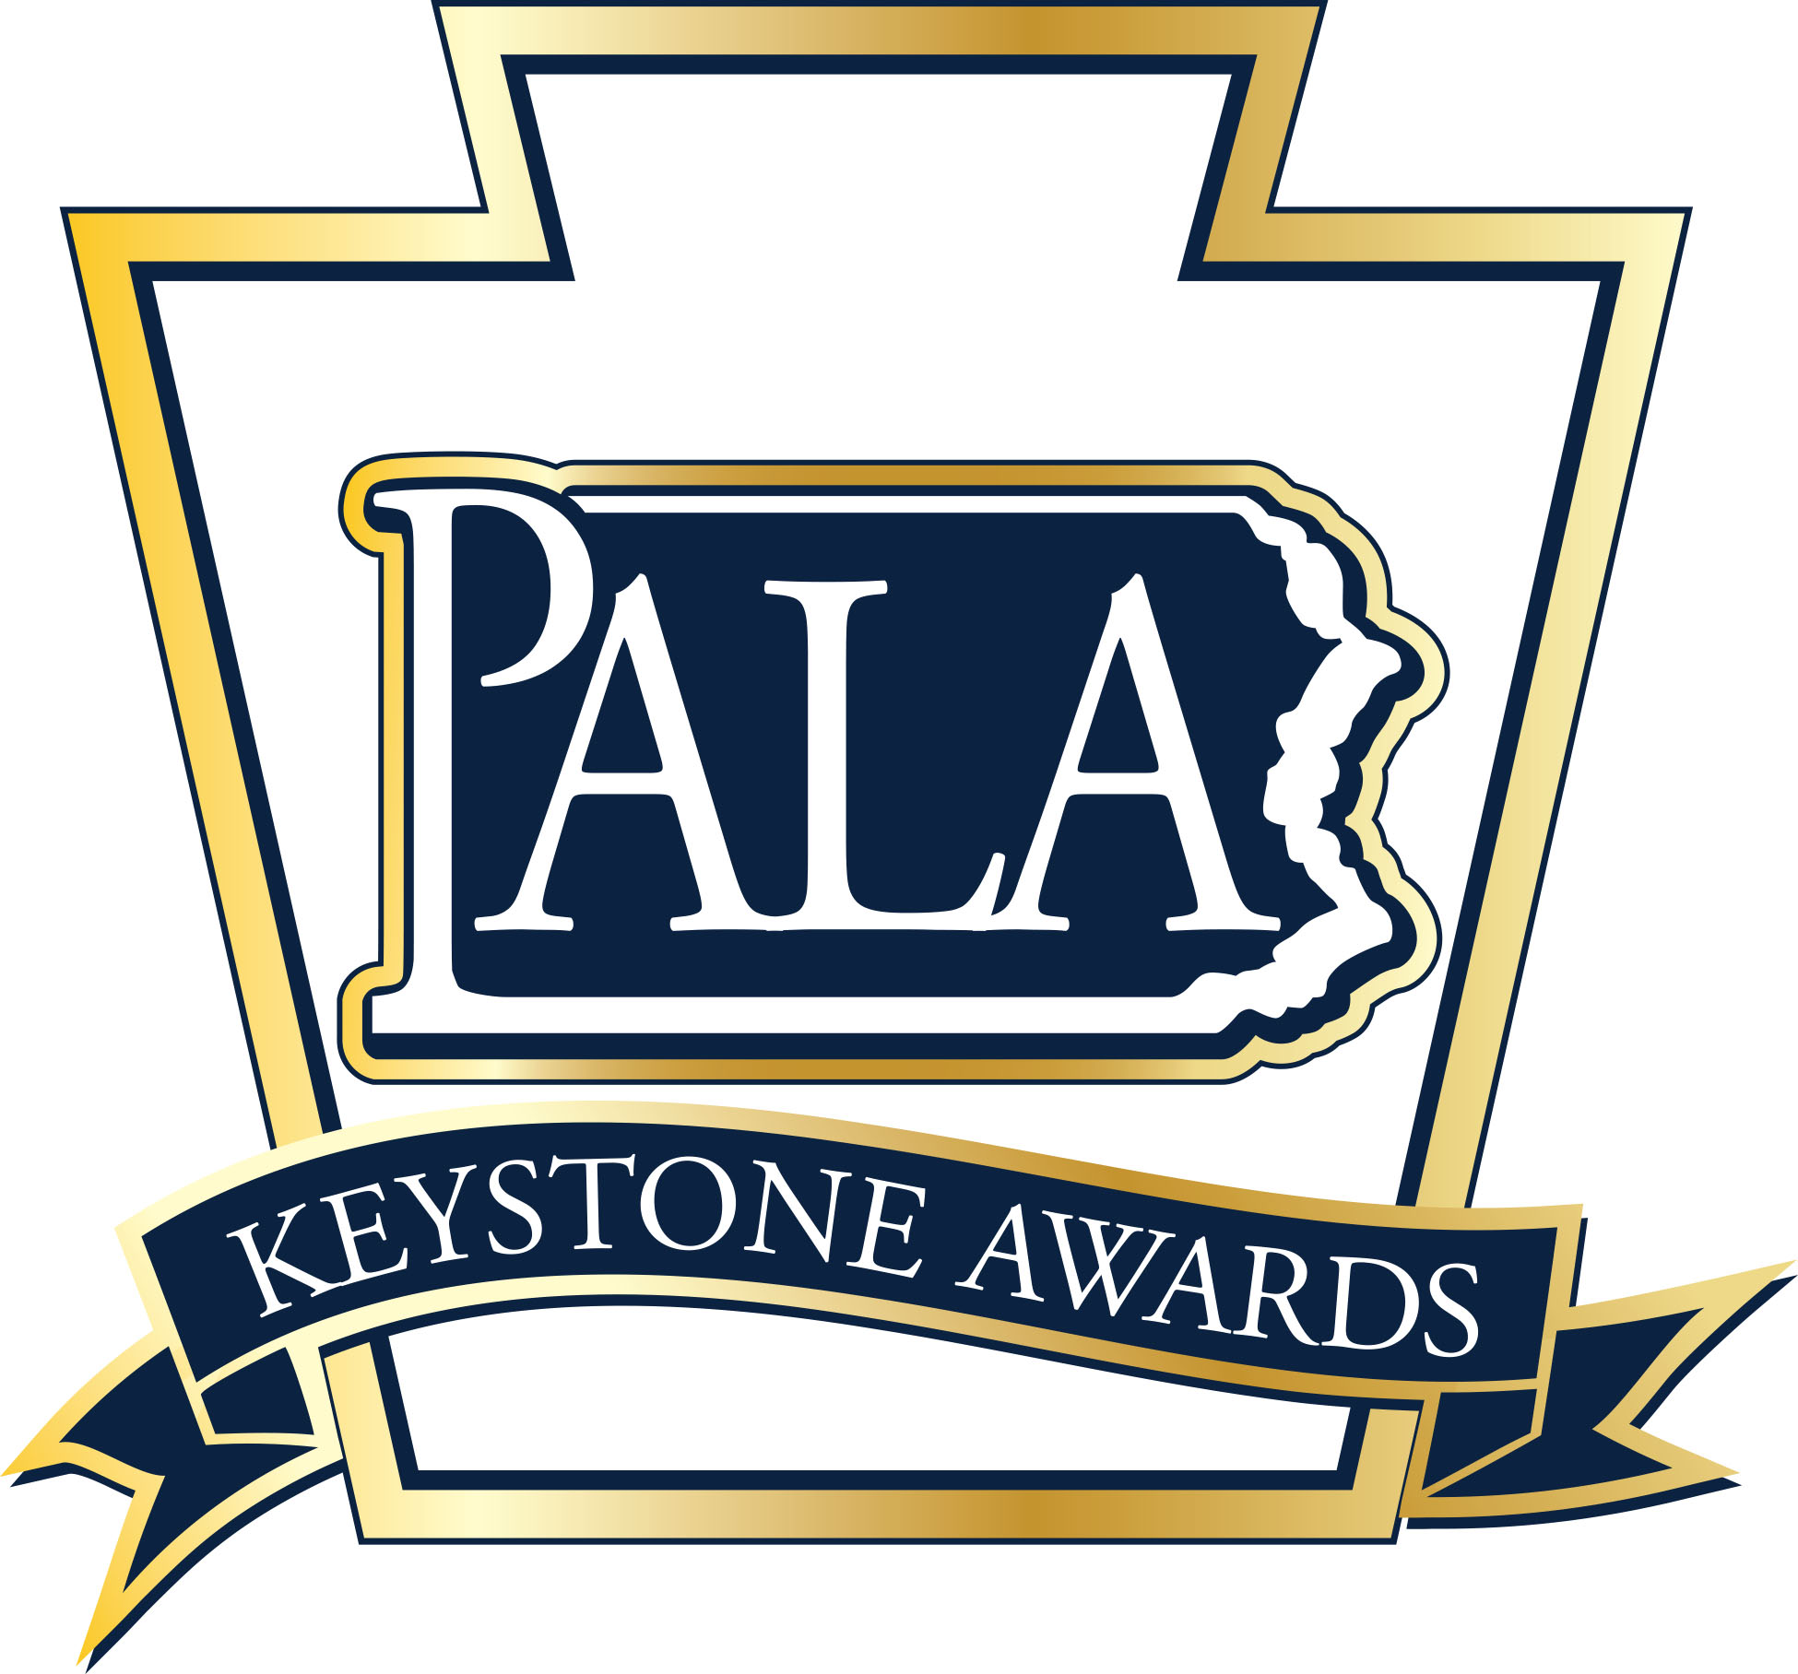
2020
Industry Partner of the Year Award

Nomination Form

The Industry Partner of the Year Award is sponsored by the Pennsylvania Assisted Living Association (PALA) and recognizes Industry Partners who have demonstrated outstanding leadership through their dedication to PALA and the personal care and assisted living industry overall.

Nomination Guidelines: One award will be given annually at the awards ceremony held in conjunction with the PALA Annual Fall Conference. Industry Partners that are PALA Industry Partners in good standing are eligible to receive the award.

All nominations must be submitted on this form along with their history of excellence in their field. Two reference letters are required and may be from Industry Partners, their staff, Personal Care Home and Assisted Living Residence staff, residents, family members of residents, or other individuals who can support this nomination. Supporting documentation should provide evidence of the nominee’s dedication to the following:

- Supports the Personal Care Home and Assisted Living Residence industry in Pennsylvania;
- Supports PALA membership through advocacy with legislators and regulators;
- Demonstrates dedication to older adults and specifically those living in Personal Care Homes and Assisted Living Residence;
- Maintains a reputation as PALA Industry Partner and a leader in the Personal Care and Assisted Living Industry; and
- Participates with PALA Conferences and Vendor opportunities.

Industry Partner Name:___________________________________________________________________________________________

Industry Description: _____________________________________________________________________________________________

Industry Partner Address: ________________________________________________________________________________________

______________________________________________________________________________________________________________________

Industry Partner Contact Phone Number: ______________________________________________________________________

Industry Partner Contact E-mail Address: ______________________________________________________________________

Nominator: ________________________________________________________________________________________________________

Nominator Phone Number: ______________________________________________________________________________________

Nominator Email Address:_______________________________________________________________________________________

Nomination Checklist for PALA Industry Partner of the Year:

- Completed Nomination Form
- Two (2) reference letters
- Supporting documentation of nominee’s history of excellence that shows evidence of the following:
    - Supports the Personal Care Home and Assisted Living Residence industry in Pennsylvania;

    - Supports PALA membership through advocacy with legislators and regulators;

    - Demonstrates dedication to older adults and specifically those living in Personal Care Homes and Assisted Living Residence;

    - Maintains a reputation as PALA Industry Partner and a leader in the Personal Care and Assisted Living Industry; and

    - Participates with PALA Conferences and Vendor opportunities.

Questions? (717) 695-9734
Nomination Deadline: August 15, 2020
Return completed nomination forms and supporting documents to:
PALA 105 N. Front Street, Suite 106, Harrisburg, PA 17101
Fax to: (717) 695- 9735
Or E-mail to: info@pala.org (Subject: Keystone Awards Industry Partner)

