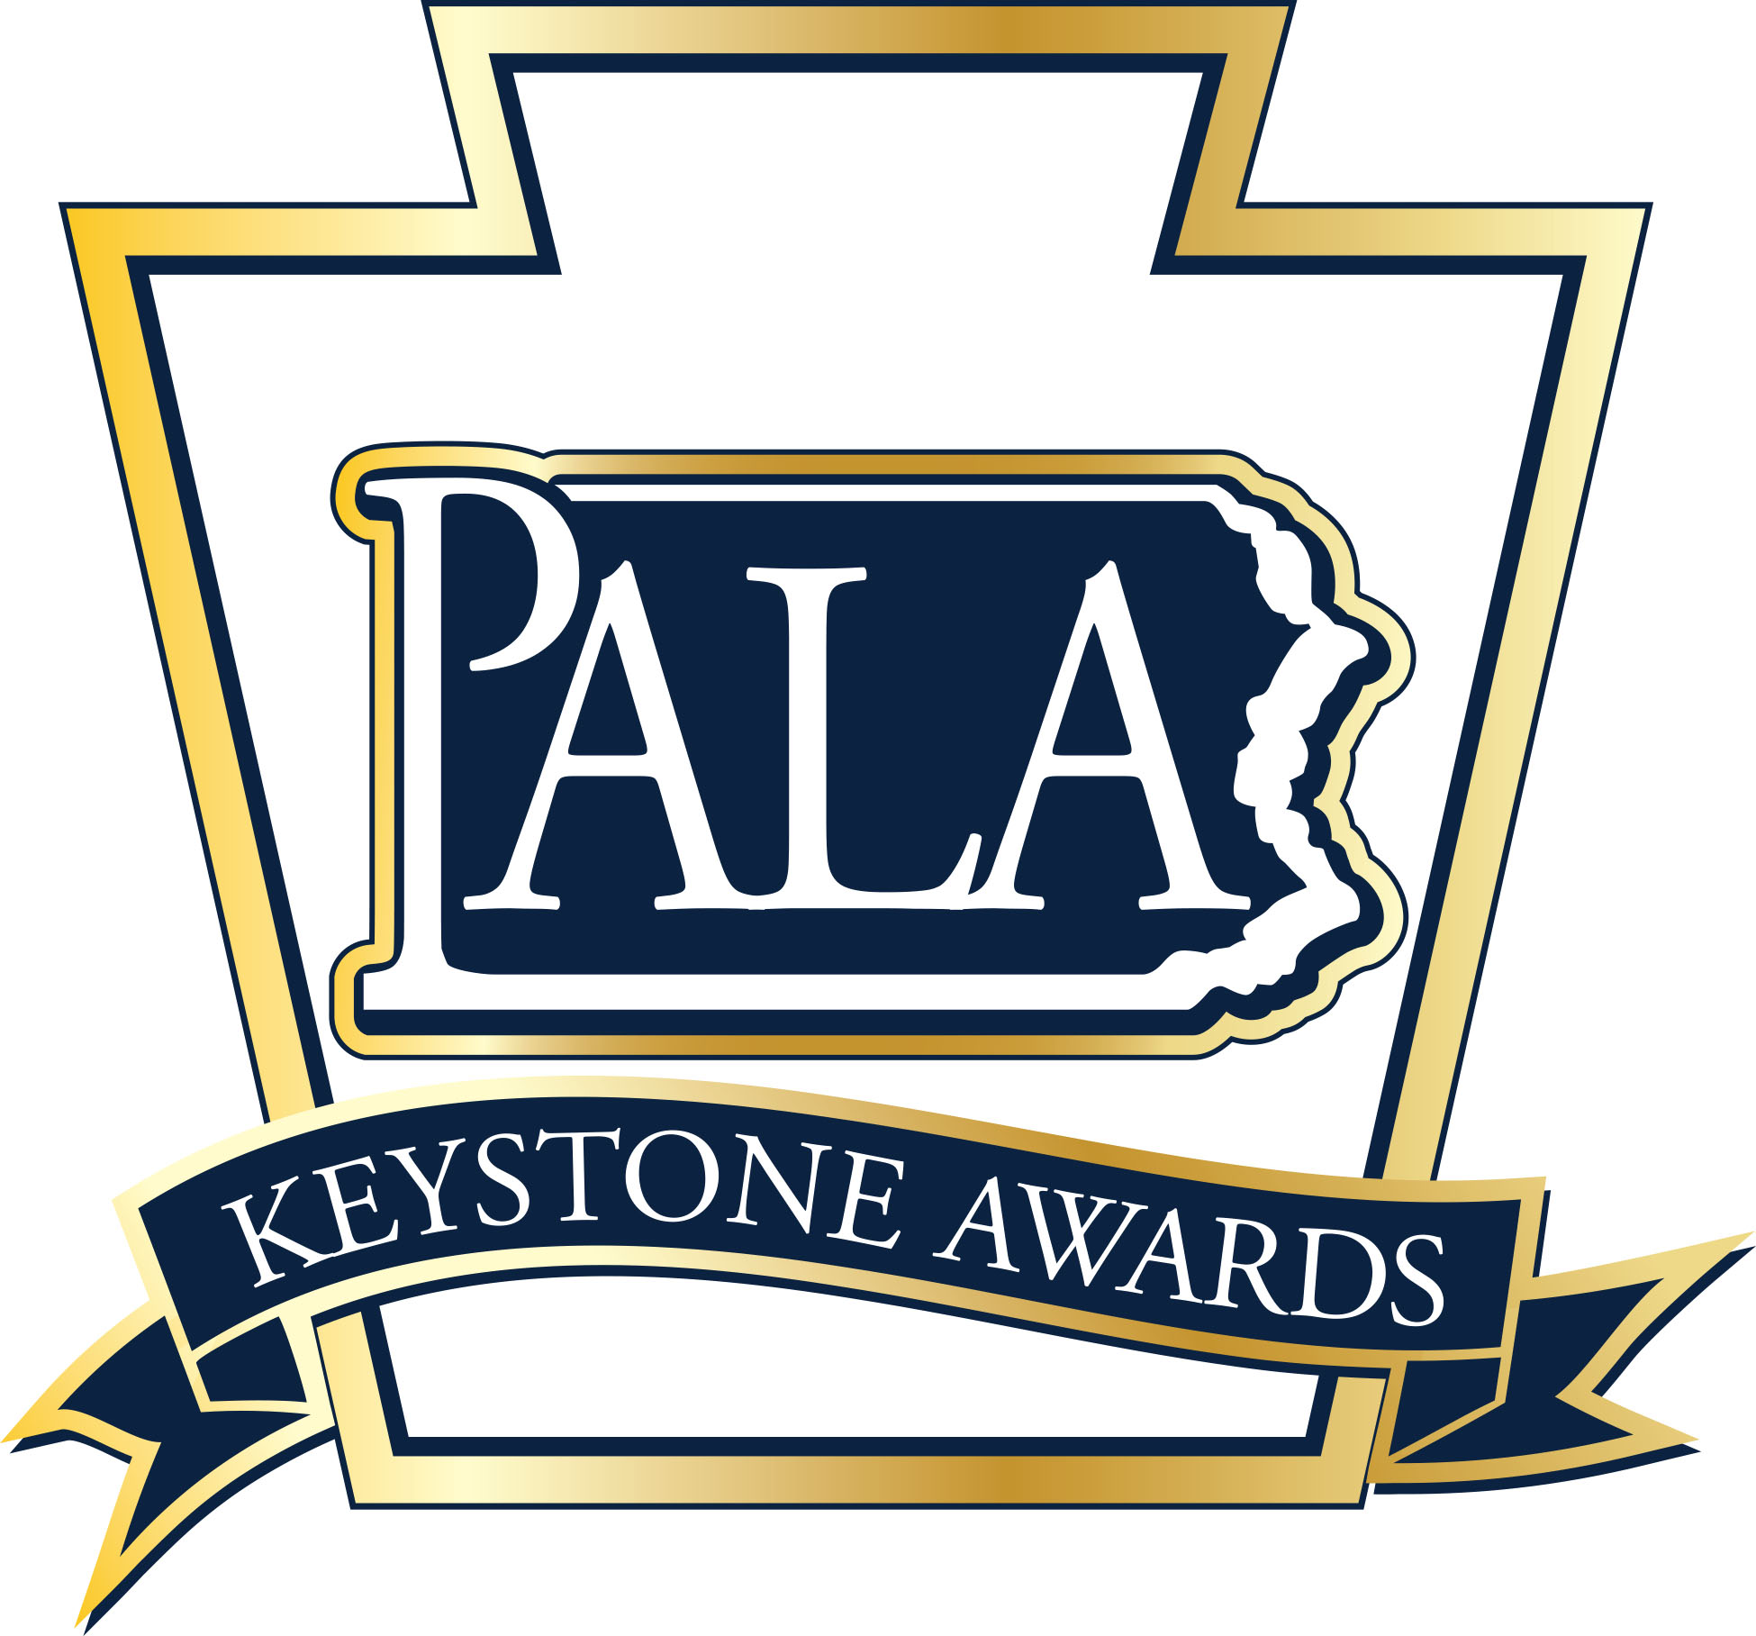
2020
Personal Care Home and
Assisted Living Residence

Outstanding Caregiver Award
Nomination Form

The Outstanding Personal Care Home and Assisted Living Residence Caregiver Award is sponsored by the Pennsylvania Assisted Living Association (PALA) and recognizes direct care and support staff from any department for their contributions that result in improved quality of life for the residents and create a work environment that supports the community and residents. This award includes; direct care staff (excludes licensed nurses), support/office staff, dietary, housekeeping, activities and maintenance departments.

Nomination Guidelines: One award will be given annually at the awards ceremony held in conjunction with the PALA Annual Fall Conference. Caregivers currently employed in Personal Care and Assisted Living communities that are PALA members in good standing are eligible to receive the award.

All nominations must be submitted on this form along with a current resume of the nominee or a listing of the nominee’s employment history and licenses/certification held. Each community is limited to a maximum of one nominee per award category per year. Two reference letters are required and may be from staff members, residents, family members of residents, or other individuals who can support this nomination. Supporting documentation should provide evidence of the nominee’s dedication to the following:
- Contributes to the quality of life for the residents
- Demonstrates person-centered care
- Treating each resident, staff member, and community guest with dignity and respect.
- Proving a secure and safe environment for each resident, staff member, and community guest;
- Brings a positive attitude of cooperation to work each day; and
- Punctuality and dedication to their employment position.

Nominee: _________________________________________________________________________________________________________________

Nominee’s Job Title:_____________________________________________________________________________________________________

Length of Service at present Community: ___________ Length of Service in this position at Community__________

Years of Service in Senior Living_______________________

PALA Member Community:_____________________________________________________________________________________________

Community Address: ____________________________________________________________________________________________________

_____________________________________________________________________________________________________________________________

Nominee E-mail: ________________________________________________________________________________________________________

Nominator: ______________________________________________________________________________________________________________

Nominator Email: ______________________________________________________________________________________________________

Nominator Telephone: ________________________________________________________________________________________________

Nomination Checklist for PALA Outstanding Caregiver of the Year:

- Completed Nomination Form
- Nominee’s Resume or overview of employment history with listing of licenses/certification held
- Two (2) letters of reference for the nominee
- Supporting documentation of nominee’s dedication that shows evidence of the following:
    - Contributes to the quality of life for the residents;

    - Demonstrates person-centered care;

    - Treating each resident, staff member, and community guest with dignity and respect;

    - Proving a secure and safe environment for each resident, staff member, and community guest;

    - Brings a positive attitude of cooperation to work each day; and

    - Punctuality and dedication to their employment position.

Questions? (717) 695-9734
Nomination Deadline: August 15, 2020
Return completed nomination forms and supporting documents to:
PALA 105 N. Front Street, Suite 106, Harrisburg, PA 17101
Fax to: (717) 695- 9735
Or E-mail to: info@pala.org
(Subject: Keystone Awards Outstanding Caregiver)

