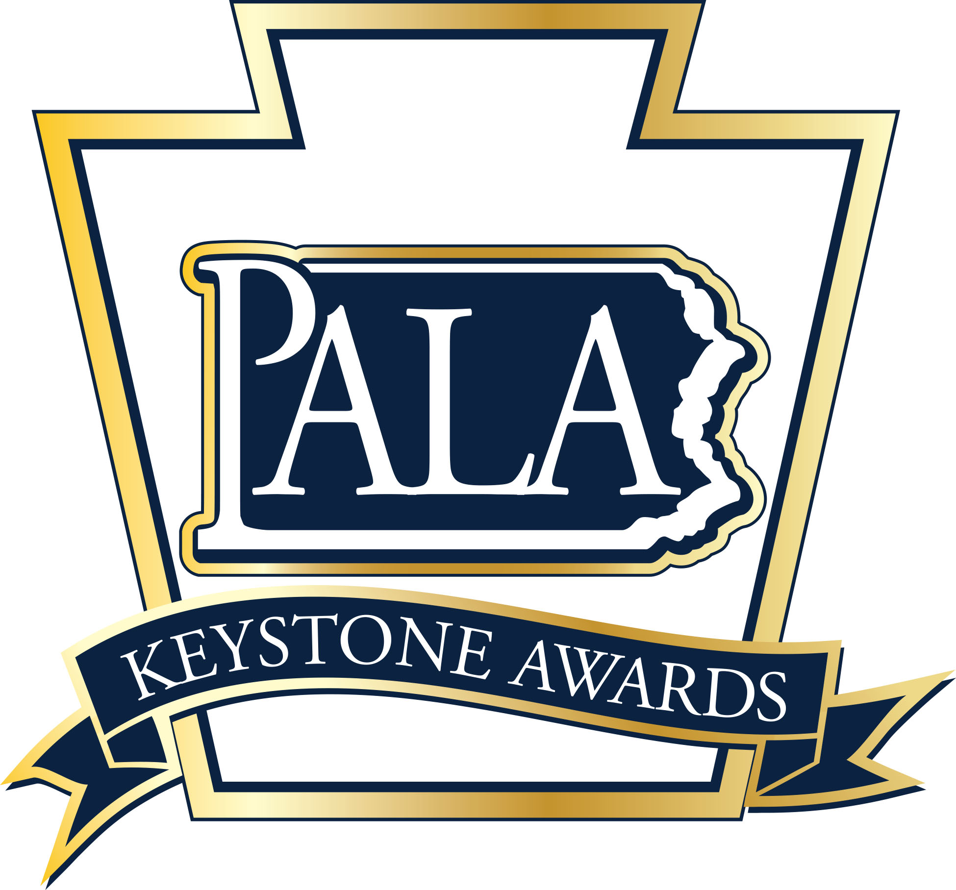
2022
Personal Care Home and
Assisted Living Residence

Administrator of the Year Award
Nomination Form

The Personal Care Home and Assisted Living Residence Administrator of the Year Award is sponsored by the Pennsylvania Assisted Living Association (PALA) and recognizes Personal Care Homes and Assisted Living Residence administrators who have demonstrated outstanding leadership through their dedication to their staff, the residents and families they serve, as well as, the personal care and assisted living industry.

Nomination Guidelines: One award will be given annually at the awards ceremony held in conjunction with the PALA Annual Fall Conference. Administrators of Record serving in Personal Care Home and Assisted Living Residence communities that are PALA members in good standing are eligible to receive the award.

All nominations must be submitted on this form along with a current resume of the nominee or a listing of the of the nominee’s employment history and licenses/certification held. Two reference letters are required and may be from staff, residents, family members of residents, or other individuals who can support this nomination. Supporting documentation should provide evidence of the nominee’s dedication to the following:
- Demonstrates leadership and teamwork skills to provide quality person-centered care to residents.
- Communicates with family members, staff, healthcare providers regarding the needs of the residents.
- Treatment of each resident with dignity and respect and protection of their resident rights;
- Exhibits dedication to staff through staff training and recognition
- Serves as a mentor and role model to staff
- Dedication to improving the personal care and assisted living industry as a whole, though public outreach, legislative services, etc.; and

Nominee: ________________________________________________________________________________________________________________

Length of Service at present Community: ________________Years of Service in Senior Living_______________________

Years as an Administrator in Personal Care/Assisted Living: _______________________________________________________

PALA Member Community:_____________________________________________________________________________________________

Community Address: ____________________________________________________________________________________________________

_____________________________________________________________________________________________________________________________

Nominee E-mail: _________________________________________________________________________________________________________

Nominator: _______________________________________________________________________________________________________________

Nominator Email: ________________________________________________________________________________________________________

Nominator Telephone: __________________________________________________________________________________________________

Nomination Checklist for PALA Administrator of the Year:

- Completed Nomination Form
- Nominee’s Resume or overview of employment history with listing of licenses/certification held
- Up to two (2) letters of reference for the nominee
- Supporting documentation of nominee’s dedication that shows evidence of the following:
    - Demonstrates leadership and teamwork skills to provide quality person-centered care to residents;

    - Communicates with family members, staff, healthcare providers regarding the needs of the residents;

    - Treatment of each resident with dignity and respect and protection of their resident rights;

    - Exhibits dedication to staff through staff training and recognition;

    - Serves as a mentor and role model to staff;

    - Dedication to improving the personal care and assisted living industry as a whole, though public outreach, legislative services, etc.; and

Questions? (717) 695-9734
Nomination Deadline: July 31, 2022
Return completed nomination forms and supporting documents to:
Fax to: (717) 695- 9735
Or E-mail to: janet@pala.org
(Subject: Keystone Awards Administrator)

