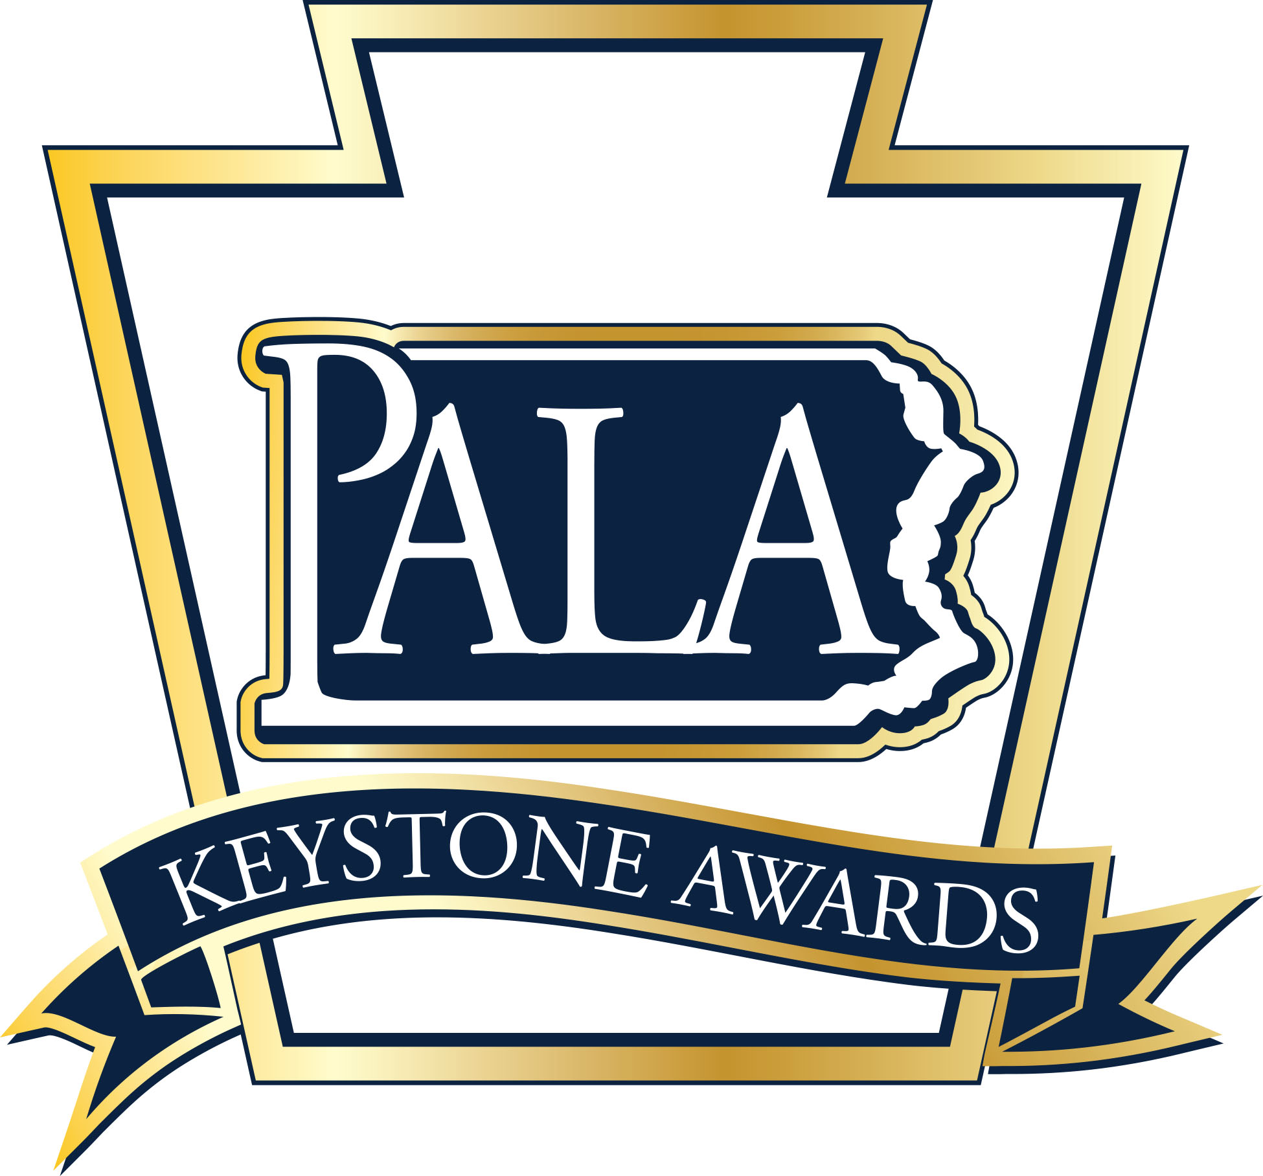
2022
Personal Care Home and
Assisted Living Residence

Best Practice Award

Nomination Form

The Personal Care Homes and Assisted Living Residence Best Practices Award is sponsored by the Pennsylvania Assisted Living Association (PALA) and recognizes personal care and assisted living communities who create innovative programs or unique approaches to provide the best services possible to its residents, employees, guests, and local community.

Nomination Guidelines: One award will be given annually at the ceremony held in conjunction with the PALA Annual Fall Conference. Personal Care Home and Assisted Living Residence communities that are PALA members in good standing are eligible to receive the award. Each community is limited to a maximum of one nominee per award per year.

All nominations must be submitted on this nomination form along with a detailed description of the nominated best practice and at least two reference letters supporting this nomination. Some example areas where a community may have provided innovative care and exhibited a best practice include, but not limited to the following:
- Resident care;
- Managed resident services
(transportation, activities, housekeeping, security, maintenance, and dining services);
- Staff recruitment and retention;
- Utilization and support of volunteers: and
- Community outreach programs.

Nominated Best Practice Title:_______________________________________________________________________________________

Description of Best Practice:_________________________________________________________________________________________

PALA Member Community:__________________________________________________________________________________________

Community Address: ________________________________________________________________________________________________

_________________________________________________________________________________________________________________________

Contact at Community for Best Practice:___________________________________________________________________________

Contact E-mail: _________________________________________________________ Contact Telephone:________________________

Nominator: ____________________________________________________________________________________________________________

Nominator Email: _____________________________________________________________________________________________________

Nominator Telephone: _______________________________________________________________________________________________

Nomination Checklist for Best Practice of the Year:
- Completed Nomination Form

- Two (2) letters of reference for the community

- MUST BE INCLUDED; Detailed description and documents for the Best Practice that include answers to the following questions:

- How long has the best practice been in place at the community;

- How does it reflect person-centered values and resident rights;

- Does this best practice improve the quality of care for residents;

- Are their documented outcomes that support the best practice; and

- Is there the ability to implement this best practice at other PALA member communities?

Questions? (717) 695-9734
Nomination Deadline: July 31, 2022
Return completed nomination forms and supporting documents to:
Fax to: (717) 695- 9735
Or E-mail to: janet@pala.org
(Subject: Keystone Awards Best Practice)

