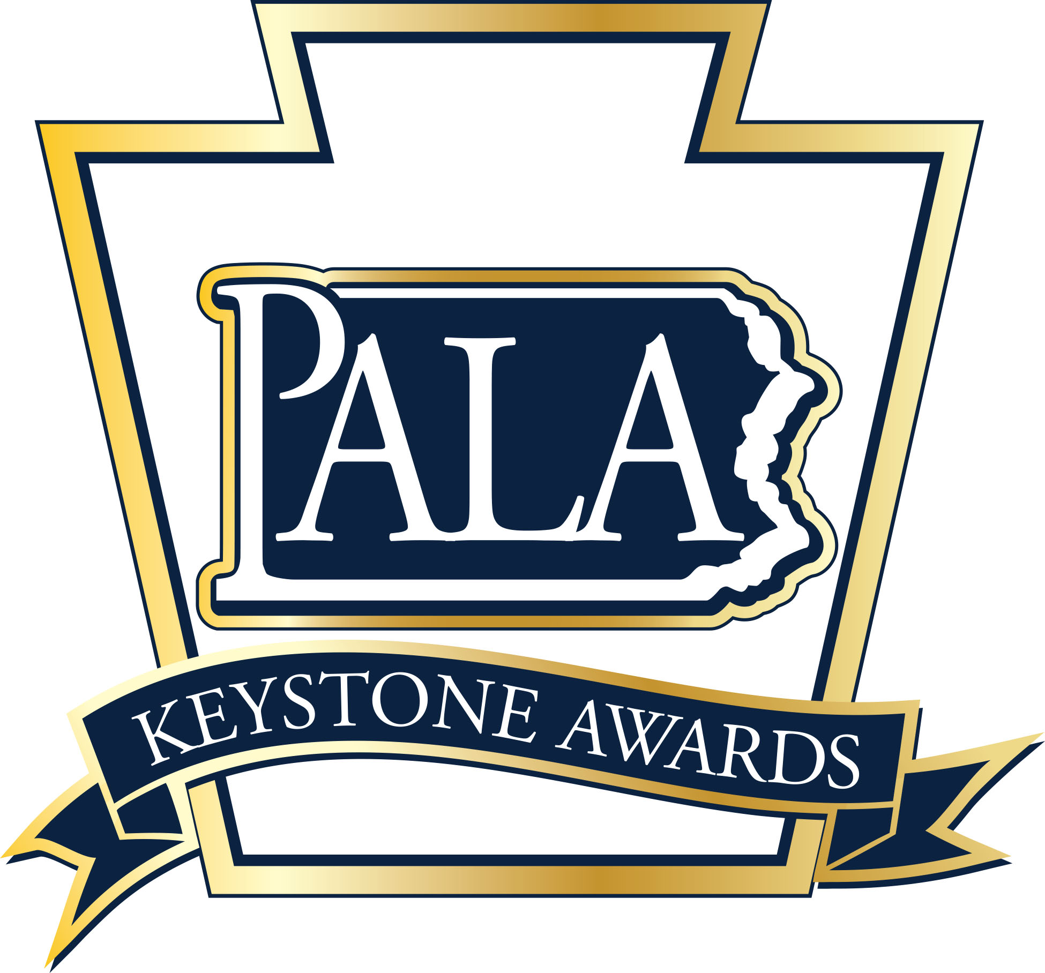
2023 Personal Care Home and
Assisted Living Residence
Outstanding Nurse Caregiver Award
Nomination Form

The Outstanding Personal Care Home and Assisted Living Residence Nurse Caregiver Award is sponsored by the Pennsylvania Assisted Living Association (PALA) and recognizes a licensed practical or registered nurse who demonstrates leadership, provides quality person-centered care and clinical expertise.

Nomination Guidelines: One award will be given annually at the awards ceremony held in conjunction with the PALA Annual Fall Conference. LPN/RN that are currently employed in Personal Care and Assisted Living communities and are PALA members in good standing are eligible to receive the award.
This award is for a Nurse that serves in a specific community and not a regional capacity.

All nominations must be submitted on this form along with a current resume of the nominee or a listing of the nominee’s employment history and licenses/certification held. Each community is limited to a maximum of one nominee per award category per year. Up to two reference letters are required and may be from staff members, residents, family members of residents, or other individuals who can support this nomination. Supporting documentation should provide evidence of the nominee’s dedication to the following:
- Communicates effectively with residents, family members and health care providers.
- Contributes to the quality of life and person-centered care for the residents.
- Demonstrates clinical expertise as a licensed nurse.
- Serves as a mentor to direct care staff.
- Proving a secure and safe environment for each resident, staff member, and community guest.
- Brings a positive attitude of cooperation to work each day.

Nominee: _________________________________________________________________________________________________________________

Nominee’s Job Title:_____________________________________________________________________________________________________

Length of Service at present Community: ___________ Length of Service in this position at Community__________

Years of Service in Senior Living_______________________ Years as a LPN/RN__________________________________________

Certifications/Licenses/Community Awards_________________________________________________________________________

PALA Member Community:_____________________________________________________________________________________________

Community Address: ____________________________________________________________________________________________________

Nominee E-mail: ________________________________________________________________________________________________________

Nominator: ______________________________________________________________________________________________________________

Nominator Email: ___________________________________________ Nominator Telephone: ________________________________

Nomination Checklist for
PALA Outstanding Nurse Caregiver of the Year

Application Must Include:

- Completed Nomination Form
- Nominee’s Resume or overview of employment history with listing of licenses/certification held
- Up to two (2) letters of reference for the nominee
- Supporting documentation of nominee’s dedication that shows evidence of the following:

    - Communicates effectively with residents, family members and health care providers.

    - Contributes to the quality of life and person-centered care for the residents.

    - Demonstrates clinical expertise as a licensed nurse.

    - Serves as a mentor to direct care staff.

    - Proving a secure and safe environment for each resident, staff member, and community guest.

    - Brings a positive attitude of cooperation to work each day.

Questions? (717) 695-9734
Nomination Deadline: July 31, 2023
Return completed nomination forms and supporting documents to:
Fax: (717) 695- 9735
Or E-mail: janet@pala.org
(Subject: Keystone Awards Outstanding Nurse Caregiver)

